**LAB # 10:**

**“ MNIST Digit Classification with CNN ”**

* **OBJECTIVE:**

In this lab we will guide you through building and training a Convolutional Neural Network (CNN) to classify handwritten digits from the MNIST dataset.

* **LAB TASKS:**

**TASK 1:** In the provided code, the model uses MaxPooling2D layers for downsampling. What if we replaced them with AvgPooling2D layers instead? Update the code to reflect this change and explain how it might affect the model's performance.

* **CODE:**

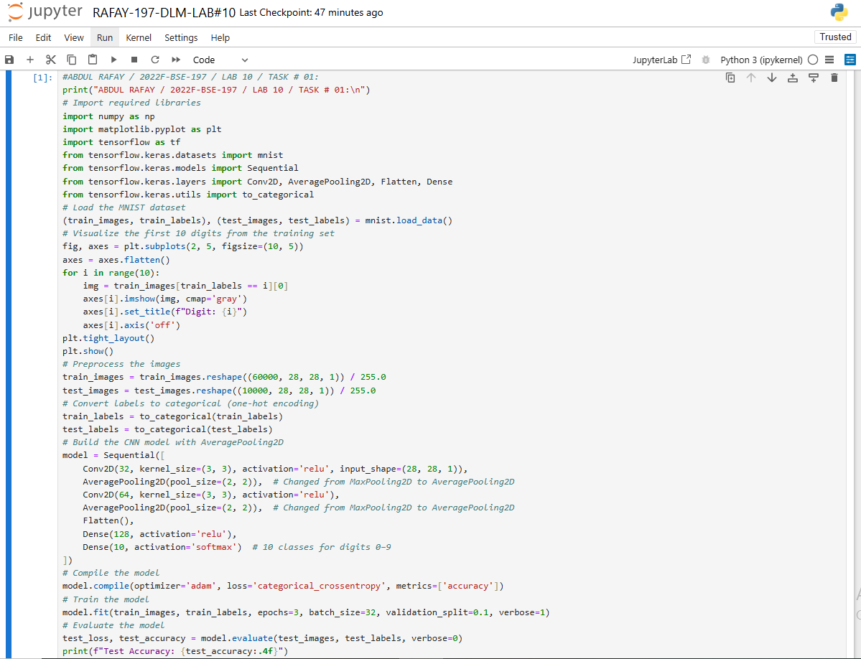

* **OUTPUT:**

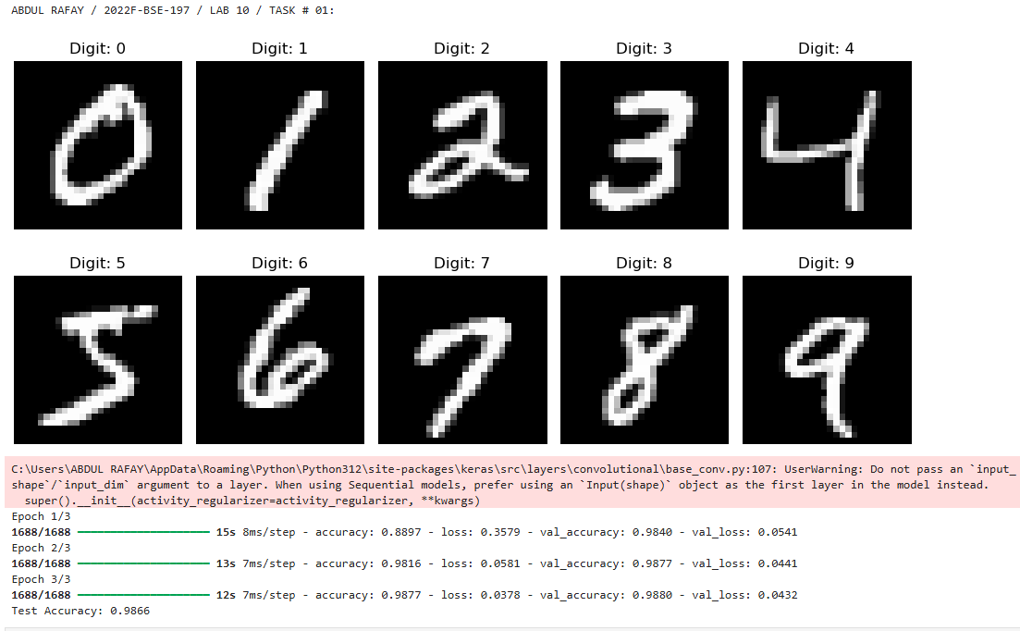

**TASK 2:** Change the number of filters in Conv2D and observe results.

* **CODE:**

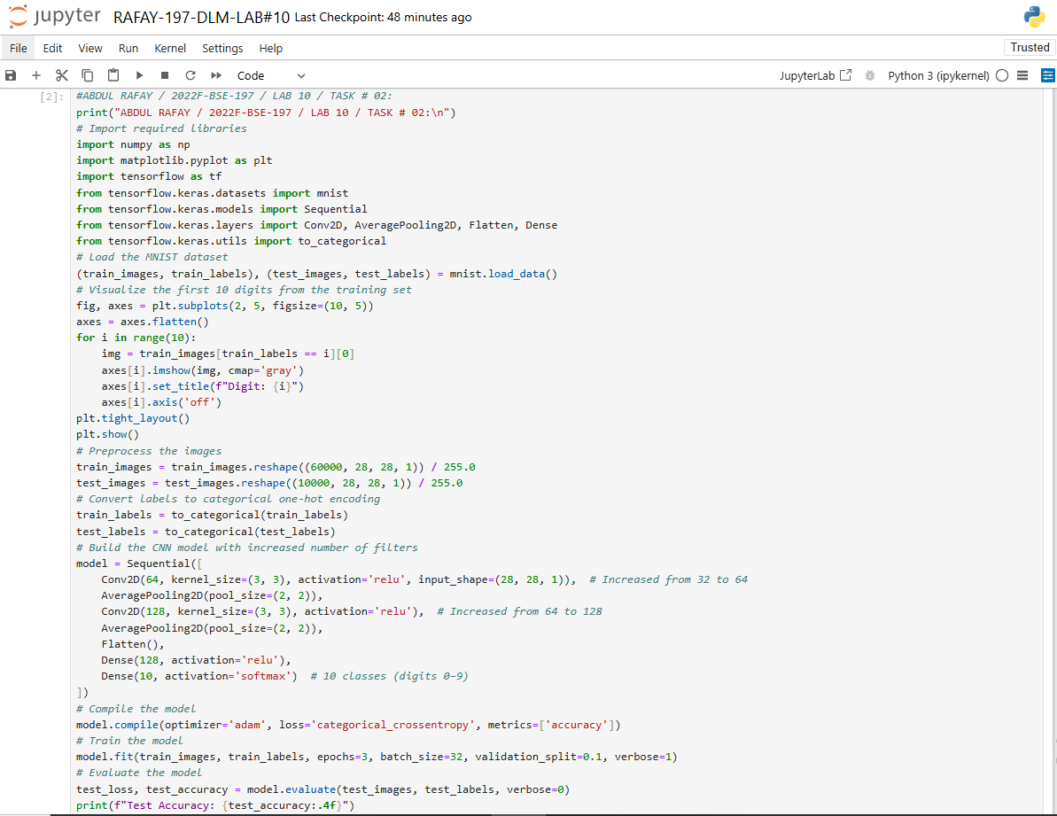

* **OUTPUT:**

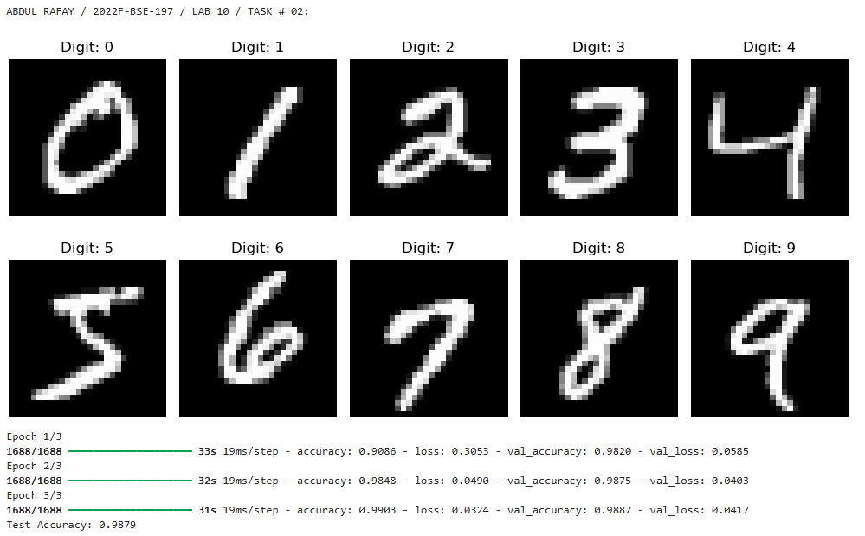

**TASK 3:** Try using the CIFAR-10 dataset instead of MNIST.

* **CODE:**

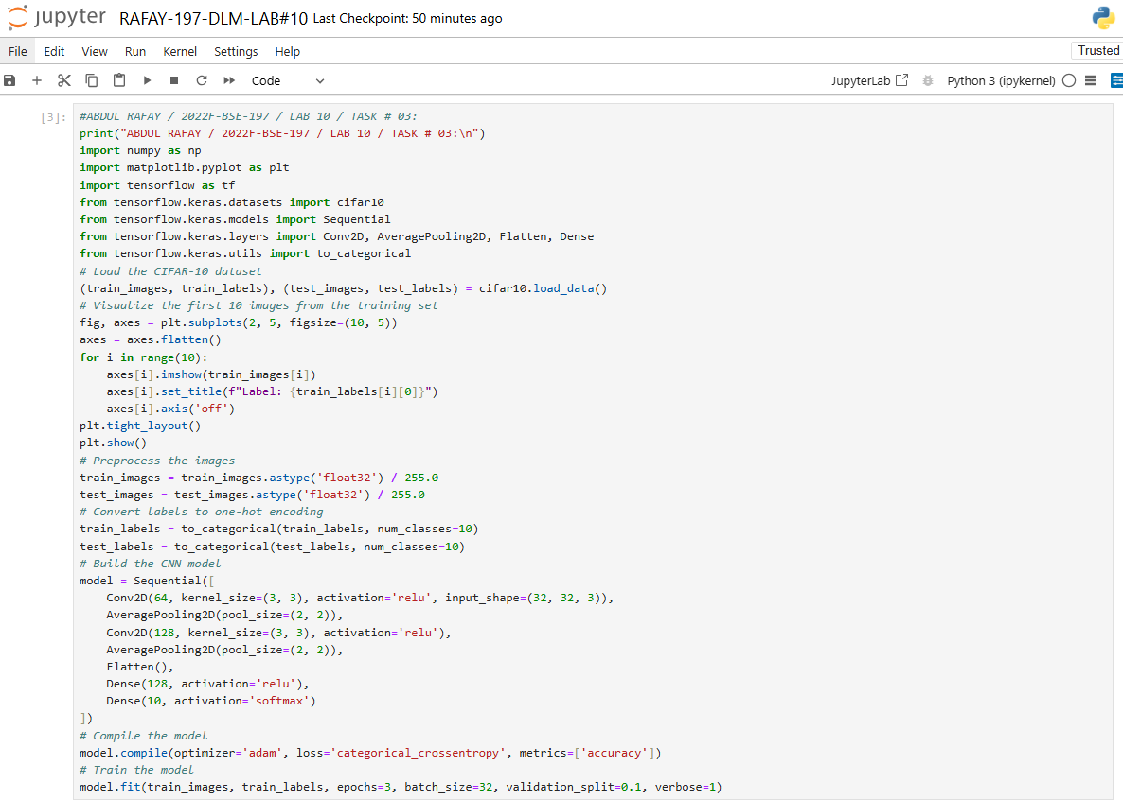

* **OUTPUT:**

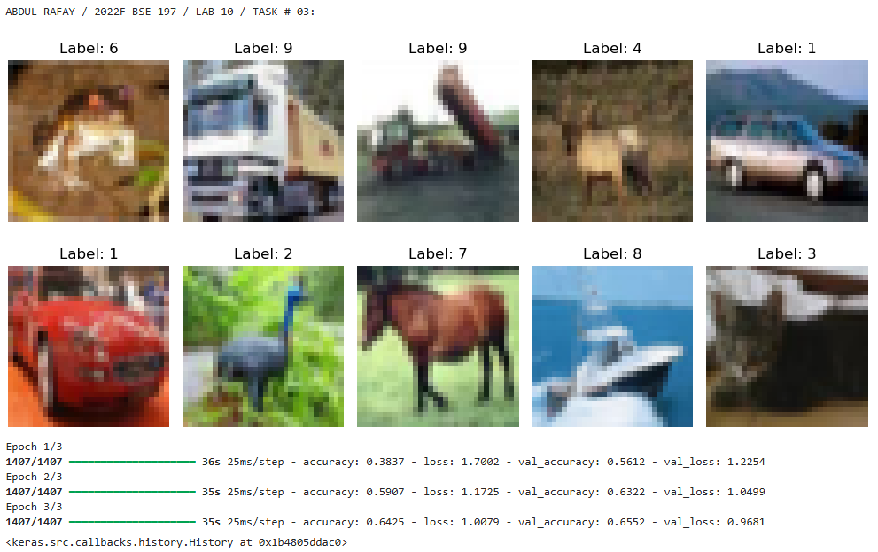

* **GITHUB UPLOAD:**
* **KAGGLE UPLOAD:**